Version Control with Git

Practical No: 1
To understand the concept of version control, its important in managing project changes and explore different version control systems.

Key Functions:
- Track every change made to a file.
- Allows multiple people to work on the same project without conflict.
- Enables reverting to previous versions if needed.
- Maintains a history of who changed what and when.

Types of version control systems
- Local Version Control Systems(Local VCS)
A local version control system operates entirely on personal machines without any connection to a remote repository. All changes and version history are stored in a local database on your computer.
- Centralized version control Systems
In a Centralized Version Control System, all files and their version history are stored in a central server. This server acts as the main source for the entire project. Developers connect to the server to access or modify files but they do not maintain a full local copy of the project, instead they work with the most recent versions pulled from the server.
- Distributed Version Control Systems
Distributed version control system contains multiple repositories. Each user has their own repository and working copy. Just committing your changes will not give others access to your changes. This is because commit will reflect those changes in your local repository and you need to push them in order to make them visible on the central repository.

Configure git with username,email

Practical No. 2

- Install Git on Windows and verify the installation.
git --version
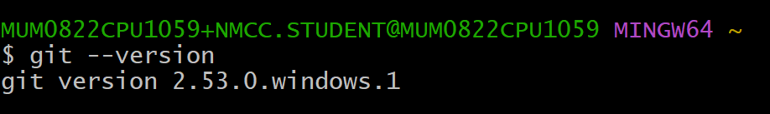

- Configure the username, email and default editor.

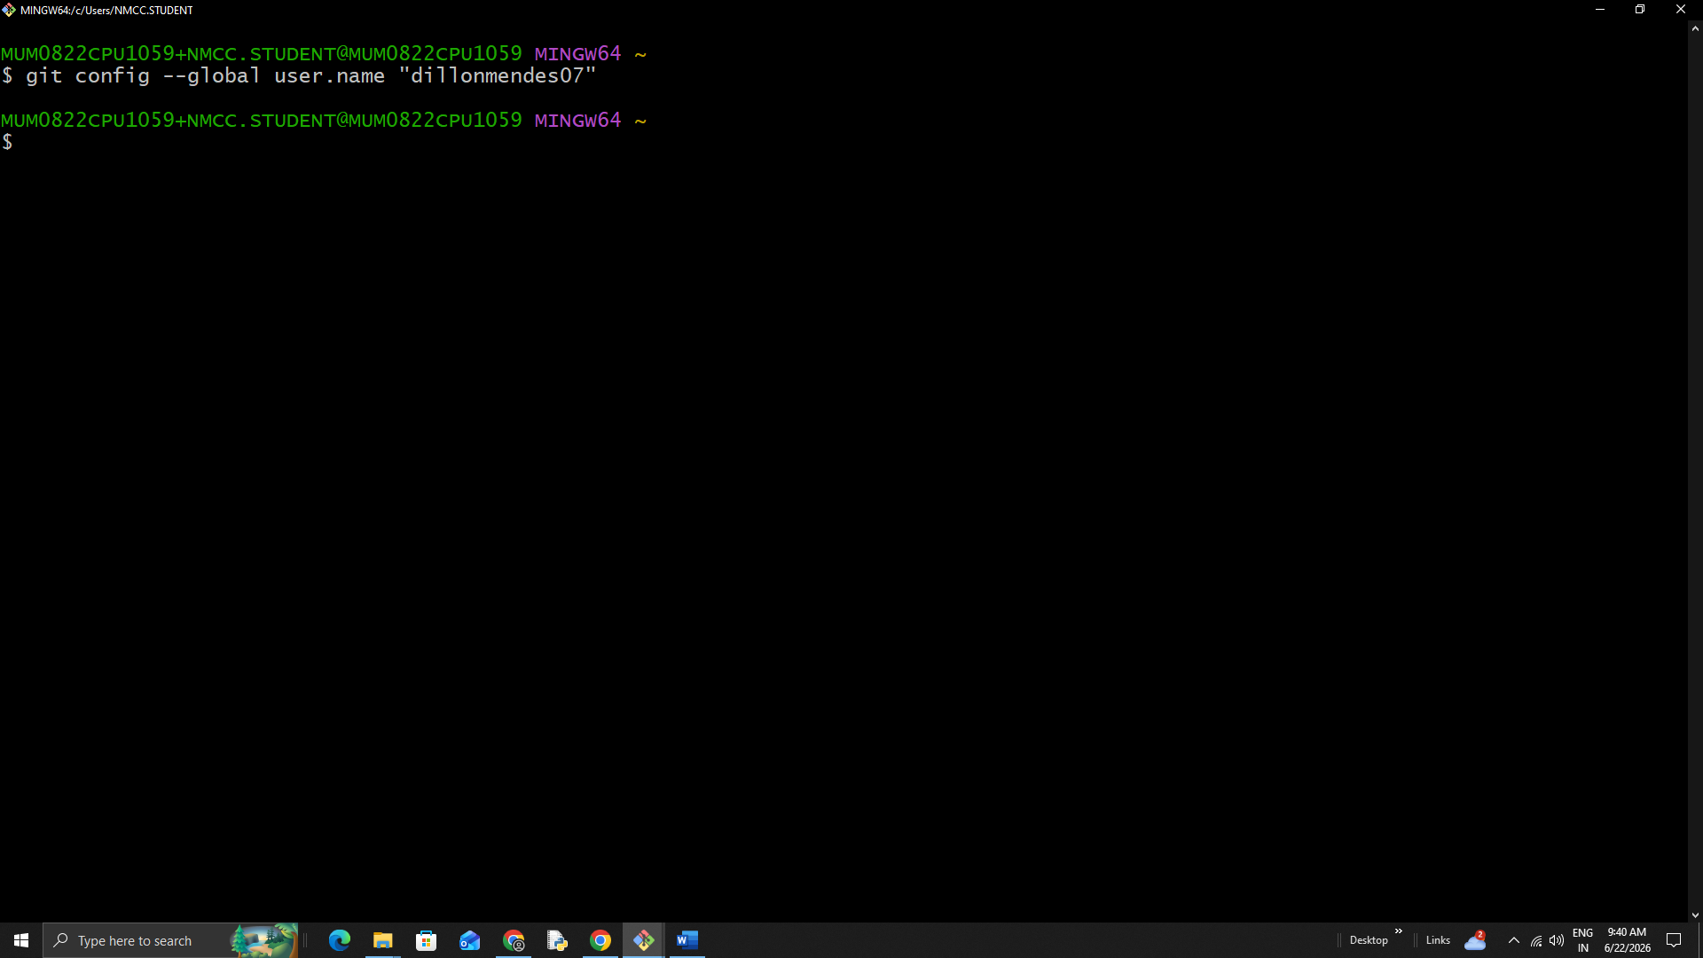

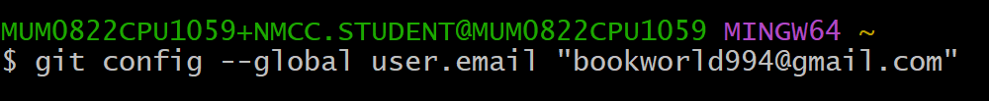

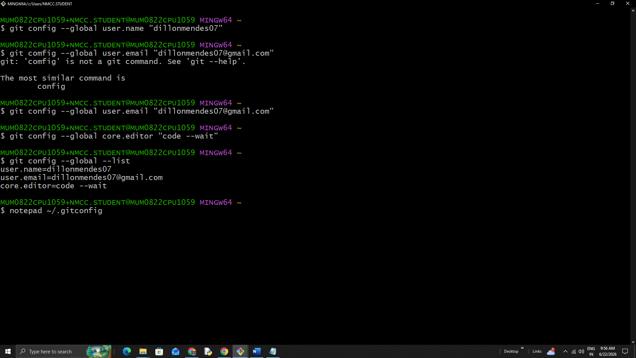





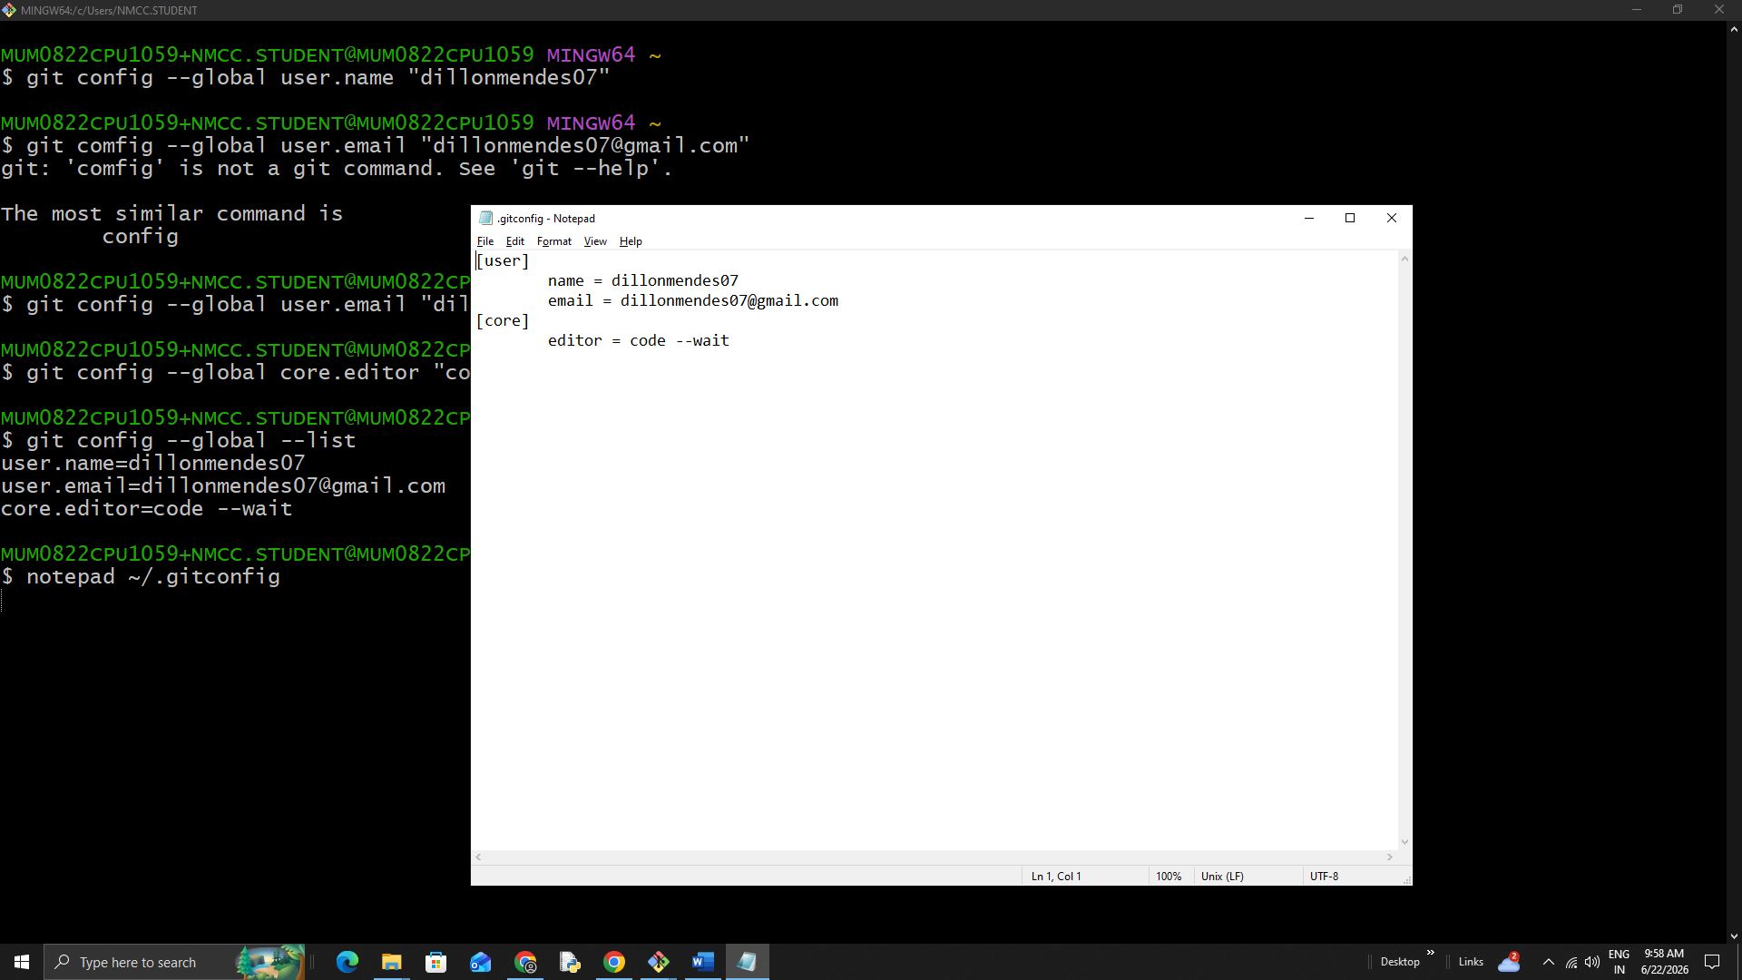

Practical 3

To explore GitHub as a cloud-based hosting platform for Git repositories and understand its features and benefits for collaboration and project management.

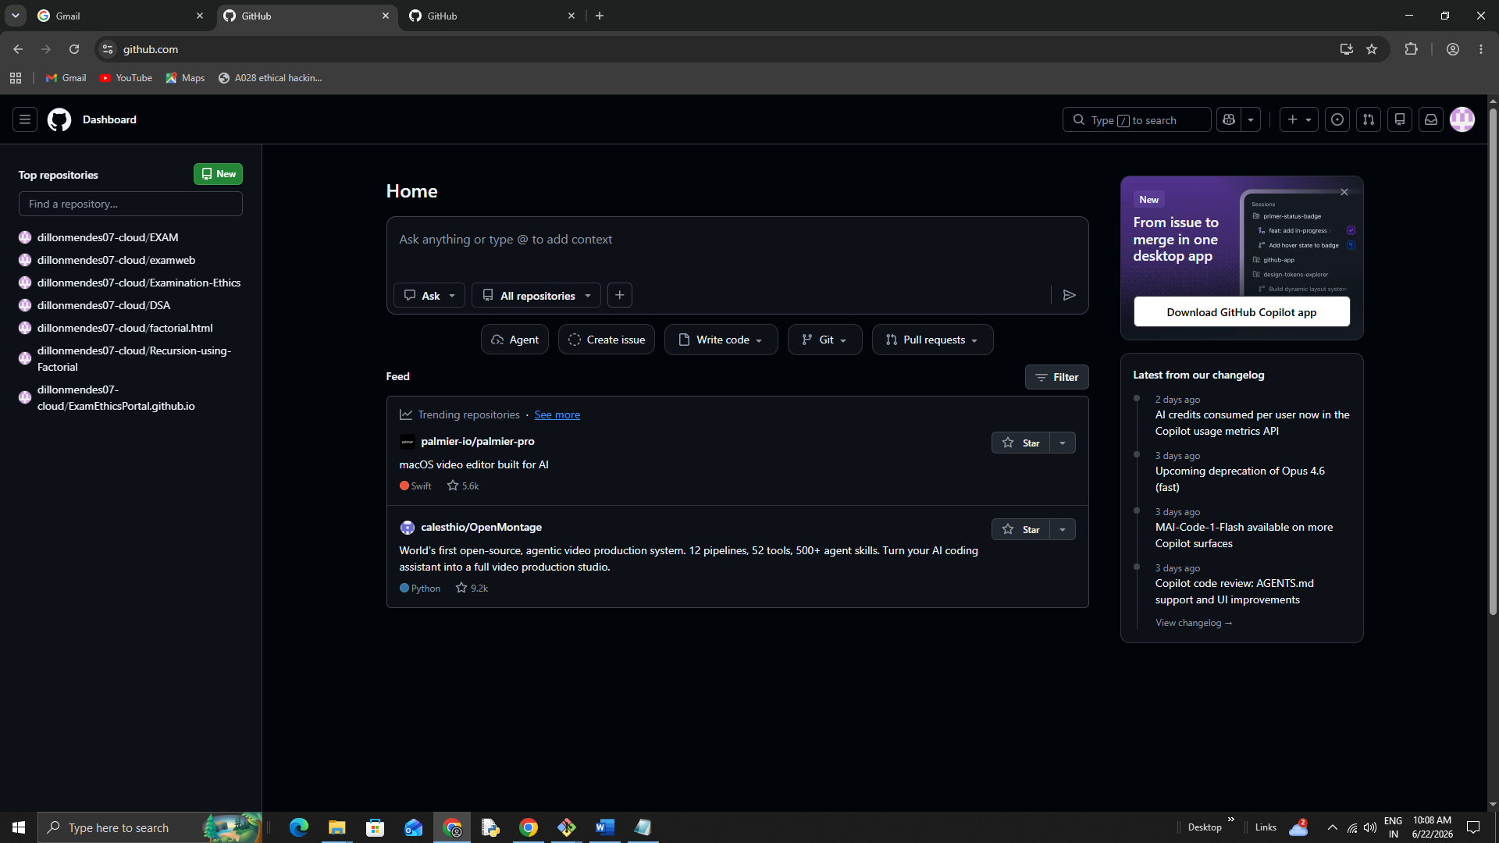

Creating a GitHub Account

1. Generate and Add SSH Keys to GitHub

SSH Keys allow secure authentication without needing to enter a password every time you interact
2. Check For existing SSH keys

Before generating a new SSH key, check if you already have one:

1. Open git bash
2.Run
ssh-keygen –t ed25519 -C “dillonmendes07@gmail.com”
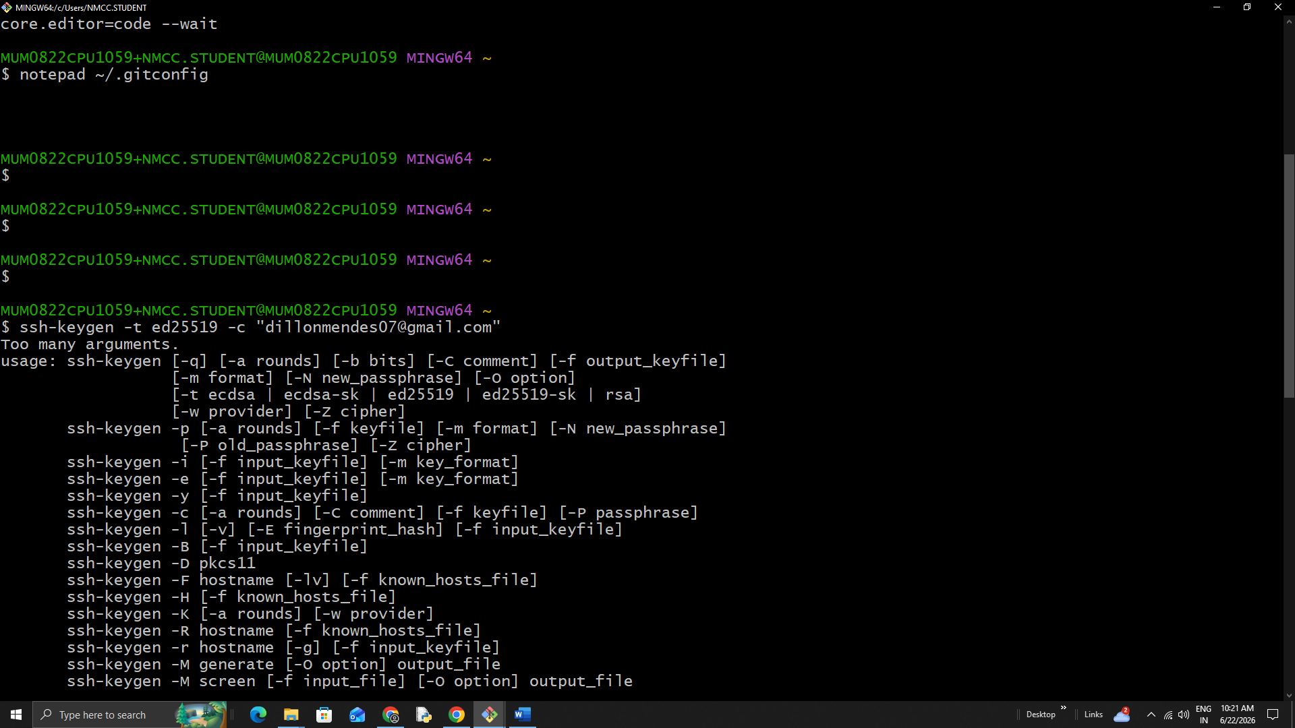

$ ssh-keygen -t ed25519 -C "dillonmendes07@gmail.com"

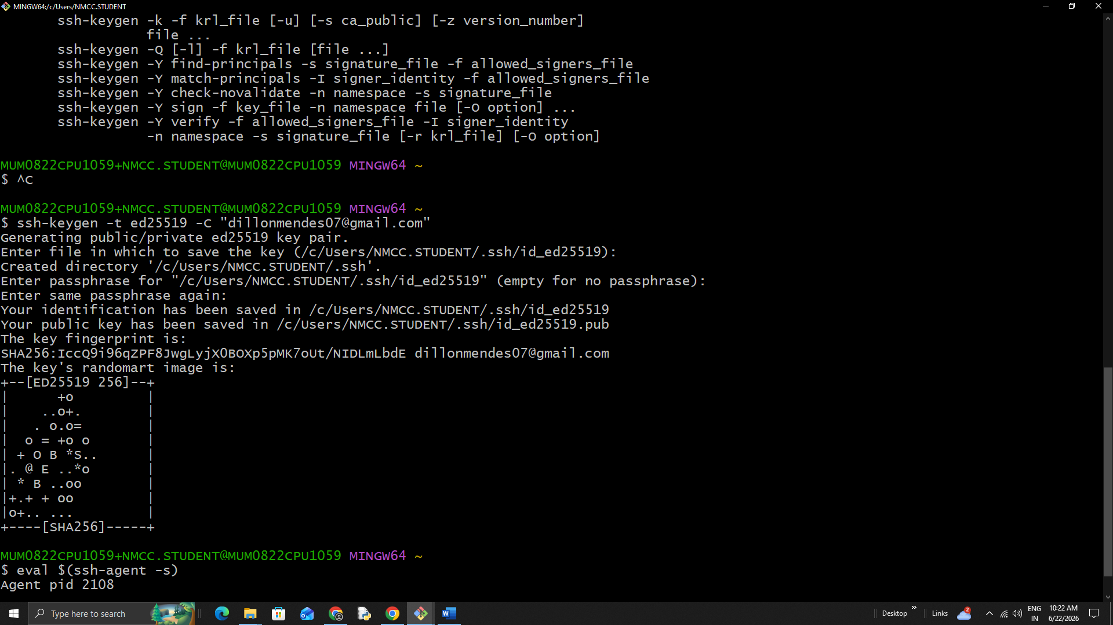

$ eval $(ssh-agent -s)

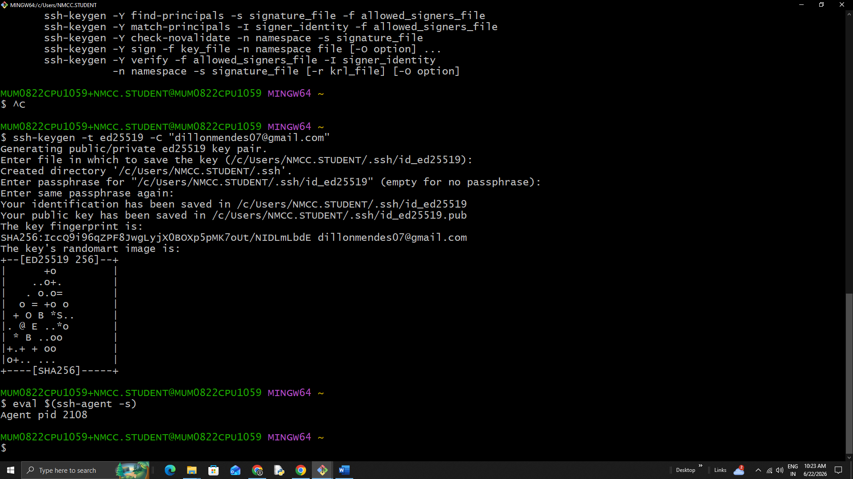

$ ssh-add ~/.ssh/id_ed25519

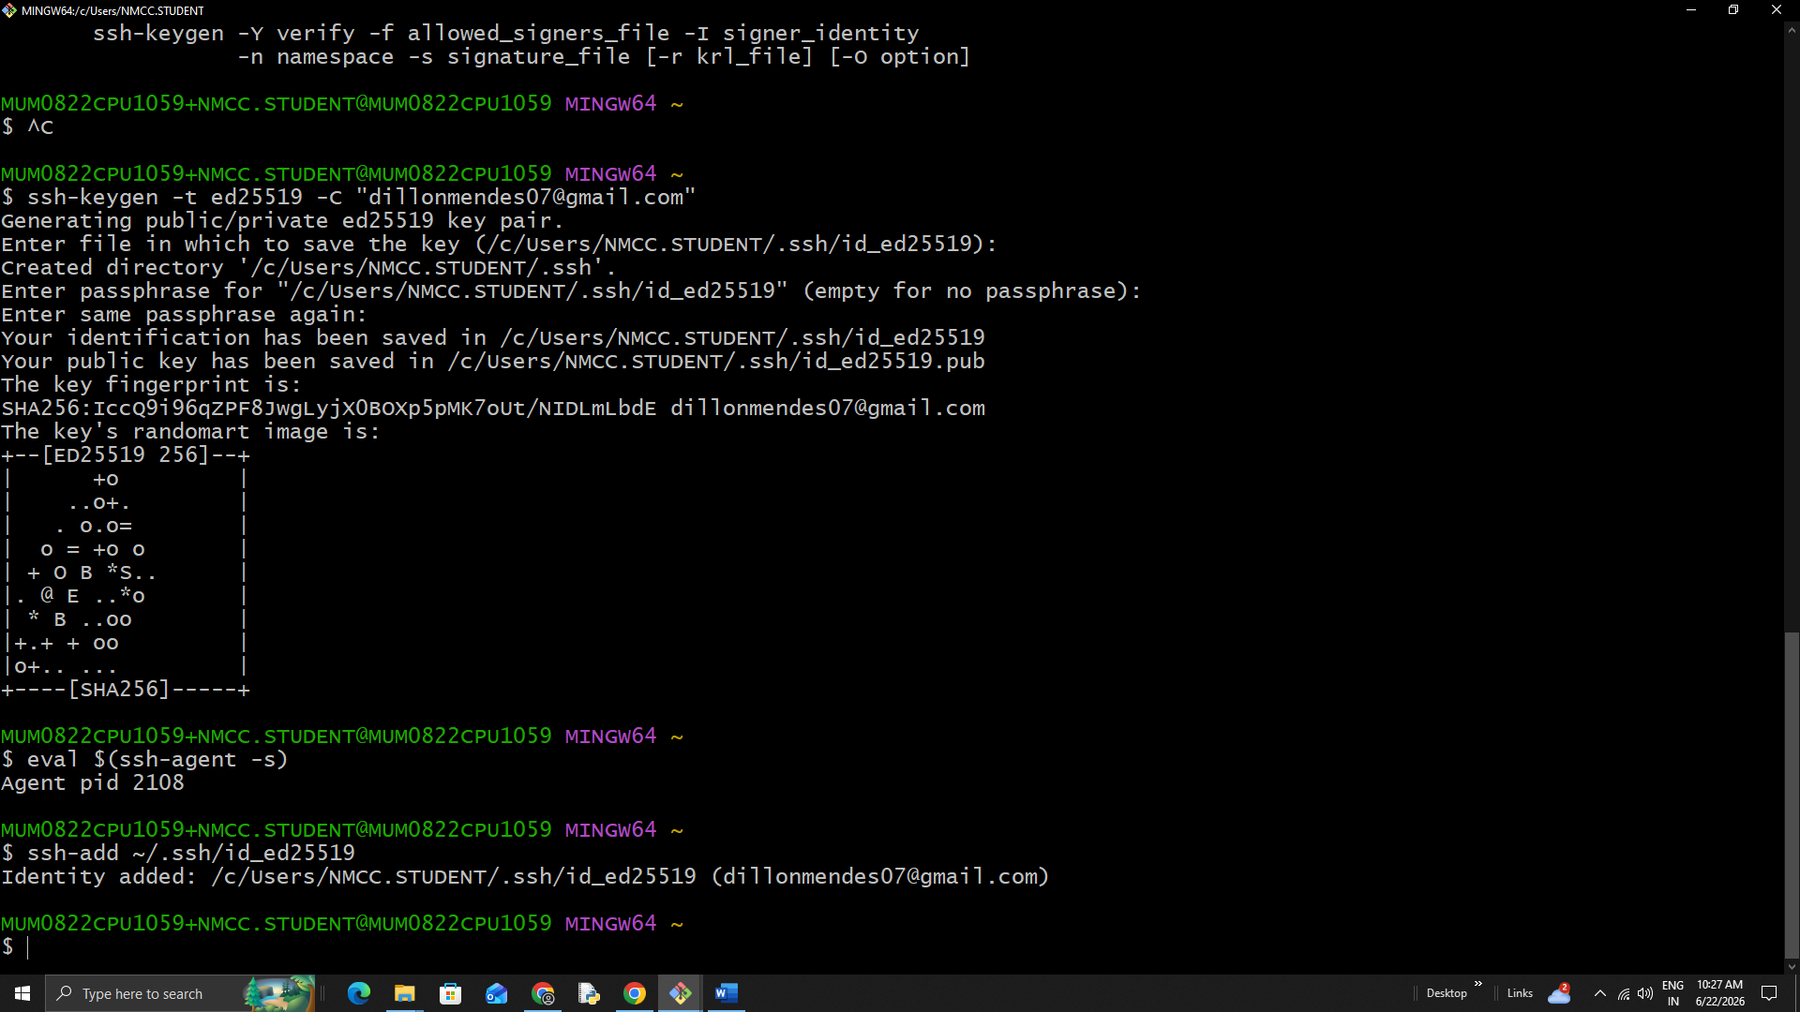

Practical 4:
To understand the concept of a GIT repository and learn to create and initialize a new local repository for tracking project files.

